Log into paypal via
https://paypal.com not clicking the link on Upsilon Nu site to pay dues.
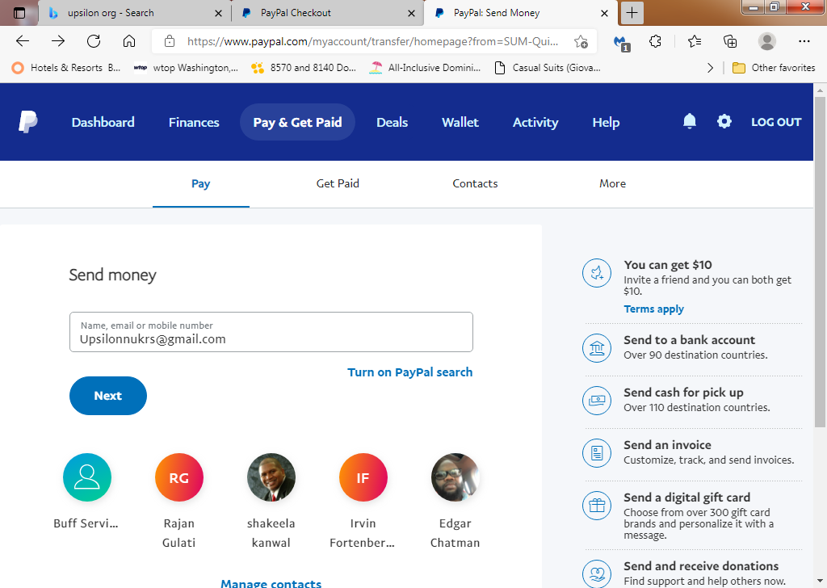
Click Send Money
Type Upsilonnukrs@gmail.com

Select Sending to a freindy
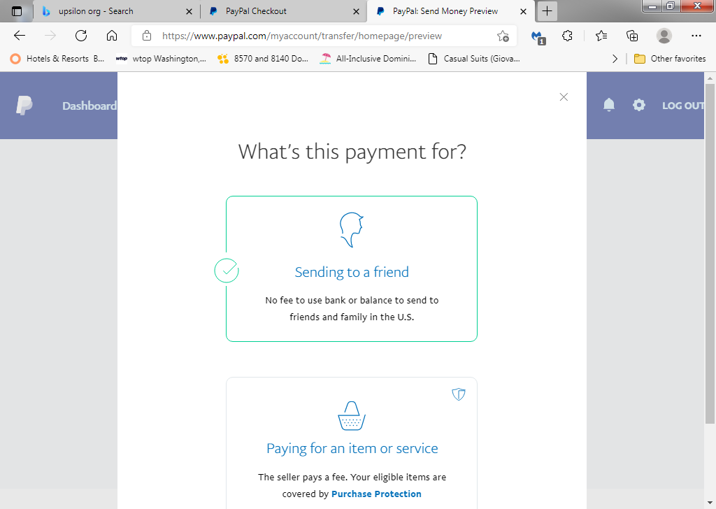

Type the amount of the Your dues
Type A note in the note section for One’s Dues and complete Recipient’s name and Recipient’s country
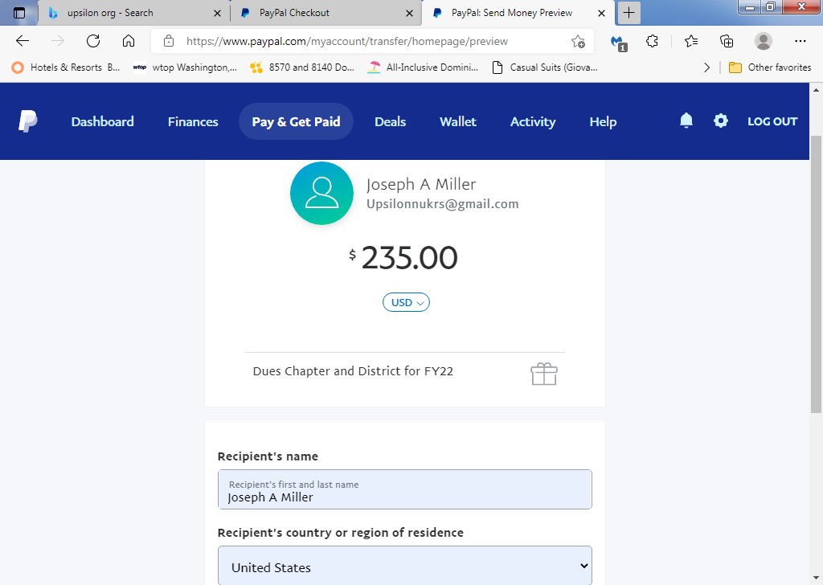
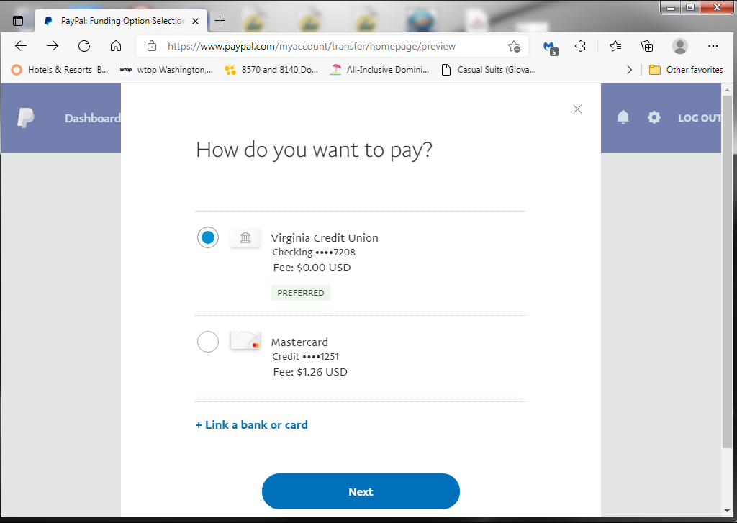
How do you want to pay? If using a bank account, NO Fee, if using a Credit Card, a fee will be added.
Chapter will get their correct amount of the transaction and PayPal will get their correct amount for the use of the Credit Card.

Click Continue
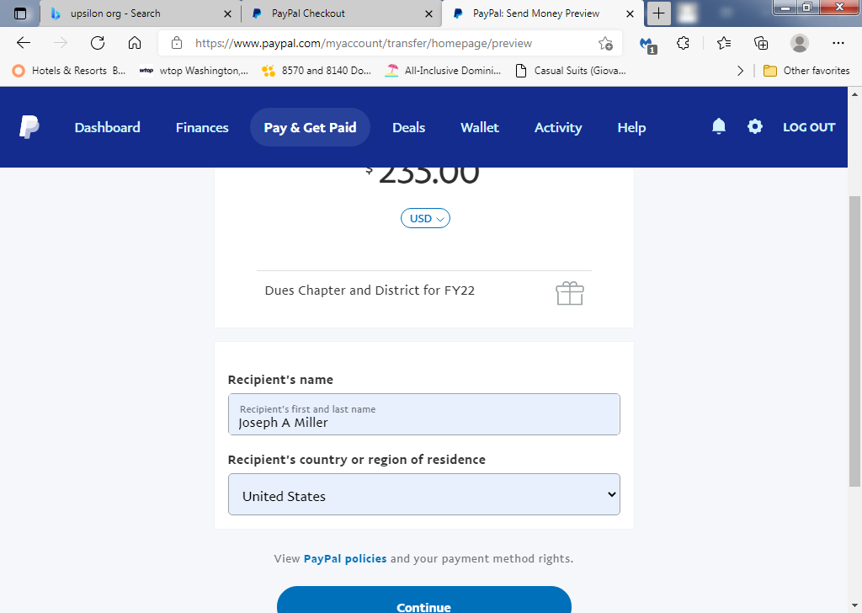
You are done!

